19F-0228

CS E

Code 5

#include<iostream>

#include<cstdlib>

#include<string>

using namespace std;

class ProjectIncharge

{

protected:

float Medical;//medical allowance

float House;//house rent

float Car;//car expenditure

float overtime;//once in a week

float salary;

public:

ProjectIncharge() {}

void setData1()

{

Medical = 10;

House = 5;

Car = 2;

overtime = 1000;

}

void getSalary1()

{

cout << "Project incharge salary is 50000 set by the Govt Admin" << endl;

salary = 50000;

cout << "\tBasic Pay = " << salary << endl;

cout << endl << "After reviewing Some Policies" << endl;

cout << "i.e" << endl;

cout << " Add Medical Allowance = 10 % " << endl;

cout << " Deducting House Rent = 5 % " << endl;

cout << " Addition of overtime = 1000 " << endl;

cout << " Deducting Car Expenditures = 2 % " << endl << endl;

cout << "\tGross Pay = " << overtime + salary + (1 / Medical) - (1 / House) - (1 / Car) << endl << endl;

}

friend class Assistant;

friend class Employee;

};

class Assistant

{

ProjectIncharge Base_obj;

public:

Assistant() {}

void setData2()

{

Base_obj.Medical = 8;

Base_obj.House = 4;

Base_obj.overtime = 2 * 1000;

}

void getSalary2()

{

cout << "Assistant salary is 40000 set by the Govt Admin" << endl;

Base_obj.salary = 40000;

cout << "\tBasic Pay = " << Base_obj.salary << endl;

cout << endl << "After reviewing Some Policies" << endl;

cout << "i.e" << endl;

cout << " Add Medical Allowance = " << Base_obj.Medical << " %" << endl;

cout << " Deducting House Rent = " << Base_obj.House << " %" << endl;

cout << " Addition of overtime = " << Base_obj.overtime << " pkr" << endl << endl;

cout << "\tGross Pay = " << (Base_obj.overtime) + Base_obj.salary + (.80) - (.4) << endl << endl;

}

friend class Employee;

};

class Employee

{

ProjectIncharge Base_obj;

Assistant obj_A;

float Rate;

float Hours;

public:

Employee() {}

void setData3()

{

Base_obj.Medical = 5;

int option;

cout << "Press 1 for Hourly Worker " << endl;

cout << "Press 2 for Daily Worker " << endl;

cin >> option;

if (option == 1)

{

cout << "Input the worked Hours" << endl;

cin >> Hours;

cout << "Input the Rate per hour" << endl;

cin >> Rate;

cout << "Your pay is " << Hours * Rate + .5 << " pkr" << endl;

}

else if (option == 2)

{

cout << "Input the Rate per hour" << endl;

cin >> Rate;

cout << "Your pay is set by 8 hours of working" << endl;

cout << "Your pay is " << 8 * Rate + .5 << " pkr" << endl;

}

}

};

int main()

{

ProjectIncharge objP;

objP.setData1();

objP.getSalary1();

Assistant objA;

objA.setData2();

objA.getSalary2();

Employee objE;

objE.setData3();

}

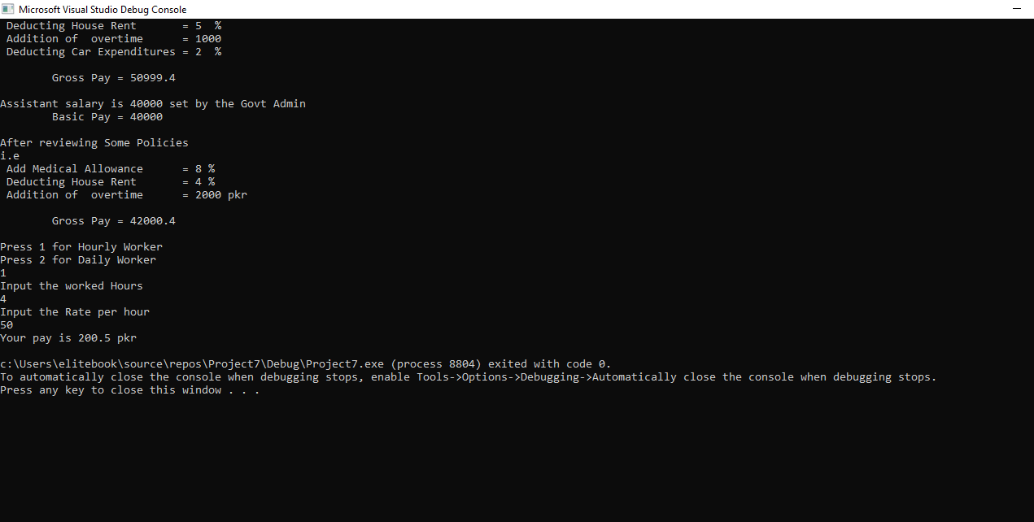

Code 4

#include<iostream>

#include<string>

#include<fstream>

using namespace std;

class BloodBank

{

protected:

string name;

string phone;

string bloodtype;

string Email;

int price;

public:

BloodBank() {}

void setName(string name)

{

this->name = name;

}

string getName()const

{

return name;

}

void setBloodgroup(string bloodgroup)

{

this->bloodtype = bloodgroup;

}

string getBloodgroup()const

{

return bloodtype;

}

string getBloodType() const

{

return bloodtype;

}

void setPrice(string blood)

{

if (blood == "O-" || blood == "o-")

{

price = 2500;

}

else price = 1500;

}

int getPrice() const

{

return price;

}

void setPhone(string x)

{

phone = x;

}

string getPhone() const

{

return phone;

}

void setEmail(string x)

{

Email = x;

}

string getEmail()const

{

return Email;

}

};

class Record :public BloodBank

{

protected:

BloodBank Array[1000];

public:

Record() {}

void Data(string choice)

{

fstream file;

static int i = 0;

if (choice == "Add New")

{

string n;

long int r;

int t;

cout << " Enter Name:" << endl;

getline(cin >> n, n);

Array[i].setName(n);

cout << " Enter Blood Group:" << endl;

cin >> n;

Array[i].setBloodgroup(n);

cout << " Enter Phone No.:" << endl;

cin >> n;

Array[i].setPhone(n);

cout << " Enter E-mail:" << endl;

cin >> n;

Array[i].setEmail(n);

cout << "Data Added" << endl;

file.open("Bank.txt", ios::out);

if (!file)

cout << "File cannot be opened!" << endl;

else

{

file << Array[i].getName() << endl;

file << Array[i].getBloodgroup() << endl;

file << Array[i].getPhone() << endl;

file << Array[i].getEmail() << endl;

}

i++;

}

if (choice == "View")

{

string Name;

string Blood;

string Phone;

string Email;

fstream file;

file.open("Bank.txt", ios::in);

if (!file)

cout << "File cannot be opened!" << endl;

else

{

file >> Name; Array[i].setName(Name);

file >> Blood; Array[i].setBloodgroup(Blood);

file >> Phone; Array[i].setPhone(Phone);

file >> Email; Array[i].setEmail(Email);

}

cout << "Please insert some data first" << endl;

for (int j = 0; j < i; j++)

{

cout << "Name = " << Array[j].getName() << endl;

cout << "Blood Group = " << Array[j].getBloodgroup() << endl;

cout << "Phone No = " << Array[j].getPhone() << endl;

cout << "E-mail = " << Array[j].getEmail() << endl;

}

}

if (choice == "Search")

{

string s;

cout << "Enter Blood Group you want to get " << endl;

cin >> s;

for (int j = 0; j < i; j++)

{

if (s == Array[j].getBloodgroup())

{

cout << "Name = " << Array[j].getName() << endl;

cout << "Blood Group = " << Array[j].getBloodgroup() << endl;

cout << "Phone No = " << Array[j].getPhone() << endl;

cout << "E-mail = " << Array[j].getEmail() << endl;

}

}

}

}

};

void write()

{

BloodBank obj;

string name, bloodgroup;

int price;

ifstream fin;

ofstream fout;

fin.open("bank.txt");

if (!fin)

cout << "File cannot be opened!" << endl;

else

{

fin >> name;

fin >> price;

fin >> bloodgroup;

obj.setName(name);

obj.setPrice(bloodgroup);

obj.setBloodgroup(bloodgroup);

fin.close();

}

}

int main()

{

ofstream fout;

fstream file;

Record obj_R;

while (1)

{

int choice;

cout << " Blood Bank Software " << endl;

cout << endl << endl << "Press 1 To Add New Data " << endl;

cout << "Press 2 to Veiw Donar" << endl;

cout << "Press 3 to Search Blood" << endl;

cout << "Press 4 to Exit" << endl;

cin >> choice;

system("cls");

if (choice == 1)

{

obj_R.Data("Add New");

}

else if (choice == 2)

{

obj_R.Data("View");

}

else if (choice == 3)

{

obj_R.Data("Search");

}

else if (choice == 4)

{

break;

}

}

return 0;

}

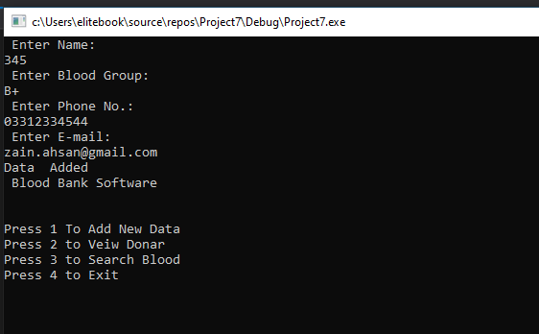

Code 1

#include <iostream>

#include <string>

using namespace std;

class Base

{

public:

string Name;

int contact;

int CNIC;

int Bus;

string Adress;

Base()

{

Name = " ";

contact = 0;

CNIC = 0;

Bus = 0;

Adress = "";

}

void setName(string s)

{

this->Name = s;

}

void setAdress(string a)

{

this->Adress = a;

}

void setCnic(int x)

{

this->CNIC = x;

}

void setContact(int x)

{

this->contact = x;

}

void setBus(int x)

{

this->Bus = x;

}

void Output()

{

cout << "Name " << Name << endl;

cout << "Adress " << Adress << endl;

cout << "CNIC " << CNIC << endl;

cout << "Phone Number " << contact << endl;

cout << "Bus Number " << Bus << endl;

}

};

class Bus :public Base

{

public:

int Route;

int Registration;

int passengerNo;

Bus()

{

Route = 0;

Registration = 0;

passengerNo = 0;

}

void setRoute(int x)

{

this->Route = x;

}

void setregNo(int x)

{

this->Registration = x;

}

void setpassNo(int x)

{

this->passengerNo = x;

}

void output()

{

Base::Output();

cout << "Route Number = " << Route << endl;

cout << "Registration Number = " << Registration << endl;

cout << "Passenger = " << passengerNo << endl;

}

};

class Route :public Bus

{

public:

int townNo;

Route()

{

townNo = 0;

}

void setTown(int x)

{

this->townNo = x;

}

void output()

{

Bus::output();

cout << "Total town in route " << Bus::Route << " is" << townNo << endl;

}

};

int main()

{

int oute;

int Registration;

int passengerNo;

int CNIC;

int contact;

int Bus;

int Town;

string Name;

string Adress;

Route obj;

int opt;

while (1)

{

cout << " Bus Route Software " << endl;

cout << endl << endl << "Press 1 To Add New Data " << endl;

cout << "Press 2 to Veiw Data " << endl;

cout << "Press 3 to Update Data " << endl;

cout << "Press 4 to Exit" << endl;

cin >> opt;

system("cls");

if (opt == 1)

{

cout << "Input Name " << endl;

cin >> Name;

cout << "Input Adress " << endl;

cin >> Adress;

cout << "Input Employee Number " << endl;

cin >> CNIC;

cout << "Input Phone Number " << endl;

cin >> contact;

cout << "Input Bus Number " << endl;

cin >> Bus;

cout << "Input Route Number " << endl;

cin >> oute;

cout << "Input Registration Number " << endl;

cin >> Registration;

cout << "Input Pass Code " << endl;

cin >> passengerNo;

cout << "Input Town Number" << endl;

cin >> Town;

obj.setName(Name);

obj.setAdress(Adress);

obj.setCnic(CNIC);

obj.setContact(contact);

obj.setBus(Bus);

obj.setRoute(oute);

obj.setregNo(Registration);

obj.setregNo(passengerNo);

obj.setTown(Town);

}

if (opt == 2)

{

obj.output();

}

if (opt == 3)

{

int choice;

cout << " Press 1 to Update Name & Adress" << endl;

cout << " Press 2 to update CNIC & Phone & Bus Number" << endl;

cout << " Press 3 to update Route & Registration & Passenger Number" << endl;

cout << " Press 4 to update Town Number";

cin >> choice;

if (choice == 1)

{

cout << "Enter Name " << endl;

cin >> Name;

cout << "Enter Adress " << endl;

cin >> Adress;

obj.setName(Name);

obj.setAdress(Adress);

obj.output();

}

else if (choice == 2)

{

cout << "Enter Employee Number" << endl;

cin >> CNIC;

cout << "Enter Phone Number" << endl;

cin >> contact;

cout << "Enter Bus Number" << endl;

cin >> Bus;

obj.setCnic(CNIC);

obj.setContact(contact);

obj.setBus(Bus);

obj.output();

}

else if (choice == 3)

{

cout << "Enter Number of towns " << endl;

cin >> Town;

obj.setTown(Town);

obj.output();

}

else if (choice == 4)

{

cout << "Enter Route Number " << endl;

cin >> oute;

cout << "Enter Reg. Number " << endl;

cin >> Registration;

cout << "Enter Passenger Number " << endl;

cin >> passengerNo;

obj.setRoute(oute);

obj.setregNo(Registration);

obj.setpassNo(passengerNo);

obj.output();

}

}

else if (opt == 5)

{

break;

}

}

system("pause");

}

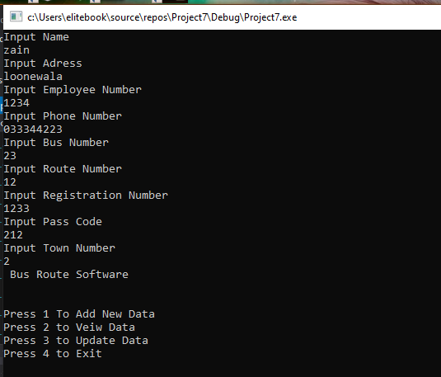

Code 3

#include<iostream>

#include<string>

#include<fstream>

using namespace std;

class Store

{

string *Items[];

int sizeIP;

int *Price[];

public:

Store() {} //

Store(int n)

{

SizeIP = n;

Items = new int[n];

Price = new int[n];

}

void setData(int x)

{

for (int i = 0; i < x; i++)

{

cout << endl << i + 1 << "Item Name = "; cin >> Items[i];

cout << endl << i + 1 << "Set Price = "; cin >> Price[i];

}

}

void output(int x)

{

for (int i = 0; i < x; i++)

{

cout << Items[i] << "\t\t\t" << Price[i] << " ";

}

cout << endl;

}

};

int main()

{

int size;

cout << endl << "With how many items you want to start the Store" << endl;

cin >> size;

Store obj;

obj.setData(size);

cout << "Item Name \t\t\t Price" << endl;

obj.output(size);

return 0;

}